

**Customized Knob Function**

**Product Requirements Document (PRD)**

***V1.1***

**Document Status:** Draft

**Document Type:** Product Requirements Document (PRD)

**Classification:** Confidential

**Department:** Digital EE

**Author: Geng Dekang**

|  |  |
| --- | --- |
| Reviewing Manager: |  |
| Document Location: |  |
| Date Released: | <Date the reviewing manager approved this document MM/DD> |

**Project: SYNC+**

|  |  |  |
| --- | --- | --- |
| **Date** | **Version** | **Note** |
| 2022.10.12 | 1.0 | Dgeng1: Initial Version |
| 2022.12.07 | 1.1 | Dgeng1: Long press from 1s to 2 s (**4.2.8**) |
|  |  |  |
|  |  |  |
|  |  |  |
|  |  |  |
|  |  |  |
|  |  |  |
|  |  |  |
|  |  |  |
|  |  |  |
|  |  |  |
|  |  |  |
|  |  |  |
|  |  |  |
|  |  |  |
|  |  |  |
|  |  |  |

Contents

1 Document overview 4

1.1 Document purpose 4

1.2 Document scope 4

2 General Assumptions 4

2.1 User 4

2.2 Vehicle 4

3 Requirement Content 5

3.1 Program 5

3.2 Interface definition 5

3.2.1手触碰旋钮金属边 5

3.2.2旋钮按下抬起 5

3.2.3 旋钮中间audiooff键按下抬起 5

3.2.4旋钮右旋 5

5. 旋钮左旋 6

3.3 User Requirements for 1.0 7

3.3.1 7

3.3.2 8

3.3.3 9

3.3.4 10

3.3.5 11

3.3.6 12

4 Supplementary instruction 13

4.1 补充说明1 13

4.2 补充说明2 13

5 Classification Key 14

6 Document Status Key 14

7 Terms, Acronyms and Definitions 14

8 Contacts 14

9 Appendix 15

# Document overview

## Document purpose

This requirements document is intended to develop customized Knob function which will be installed in Ford Vehicles’ IVI system. Under the circumstances, Knob can be customized by customer to implement climate temperature/fan speed/volume adjustment.

## Document scope

This requirement document serves as a guide for software supplier development. The requirement is used for the HMI team to design UI & UE. This document is also an important reference document for test team for developing test case.

# General Assumptions

## User

The user is assumed responsible for:

* Customers can directly turn the knob to adjust volume.
* Customers can set knob short press as fan speed/climate temperature, then directly turn the knob to adjust fan speed/temperature.
* Customers can set knob long press as Display off/Calm Screen, then directly long press the knob to display off/calm screen.

## Vehicle

For a vehicle supporting entertainment feature, the vehicle must have all of the following:

* IVI function should work well.
* The IVI system should work well with surrounding parts.

# Requirement Content

## Program

|  |  |  |  |
| --- | --- | --- | --- |
| **Program** | **Screen** | **Size** | **resolution** |
| CX727 | Portrait | 15.5’’ | 1920*1200 |
| CX727ICA | Portrait | 15.5’’ | 1920*1200 |
| CX727LFP | Portrait | 15.5’’ | 1920*1200 |
|  |  |  |  |
|  |  |  |  |
|  |  |  |  |

## Interface definition

### 3.2.1手触碰旋钮金属边

getevent查看的是 KEY_SELECT，APP监听KeyEvent.KEYCODE_DPAD_CENTER

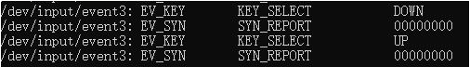

### 3.2.2旋钮按下抬起

屏幕只上报短按事件，需要app自己实现长按（只Down不UP，1s后判断为长按事件）

getevent查看的是KEY_PROGRAM，APP监听KeyEvent.KEYCODE_GUIDE



### 3.2.3 旋钮中间audiooff键按下抬起

getevent查看的是 KEY_TV，APP监听KeyEvent.KEYCODE_TV

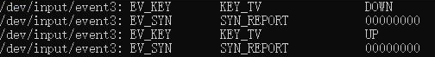

### 3.2.4旋钮右旋

getevent查看的是 KEY_VOLUMEUP，APP监听KeyEvent.KEY_CODE_VOLUME_UP



### 5. 旋钮左旋

getevent查看的是 KEY_VOLUMEDOWN，APP监听KeyEvent. KEY_CODE_VOLUME_DOWN

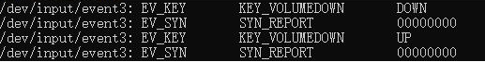

## User Requirements for 1.0

|  |  |
| --- | --- |
| Use Case ID | 3.3.1 |
| Use Case | As a customer, I want to adjust volume via knob |
| Pre-Conditions | 1. IVI is running 2. APP is working |
| Trigger | The user directly turns the knob. |
| Expected Behavior | The user can adjust the volume. |
| Post Conditions | IVI volume should match knob adjustment steps. |
| Exceptions | If there is any event which has higher priority comes in, it will be terminated or performed in the background. |

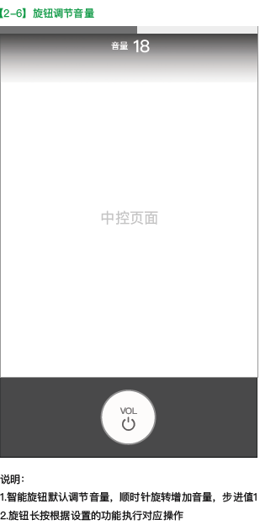

Example of 3.3.1

|  |  |
| --- | --- |
| Use Case ID | 3.3.2 |
| Use Case | As a customer, I want to adjust climate temperature via knob |
| Pre-Conditions | 1. IVI is running 2. APP is working |
| Trigger | 1. The user sets short press as temperature. 2. Short press the knob (≤800ms) 3. Turn the knob within 5 seconds |
| Expected Behavior | 1. If Dual on, user can adjust Driver & Passenger climate temperature meanwhile. 2. If Dual off, user can adjust Driver climate temperature. |
| Post Conditions | Set 5 seconds as time out value, if user does not operate knob (short press) for 5 seconds, it will recover into volume mode. |
| Exceptions | If there is any event which has higher priority comes in, it will be terminated or performed in the background. |

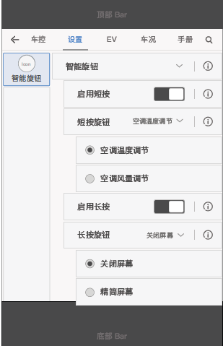 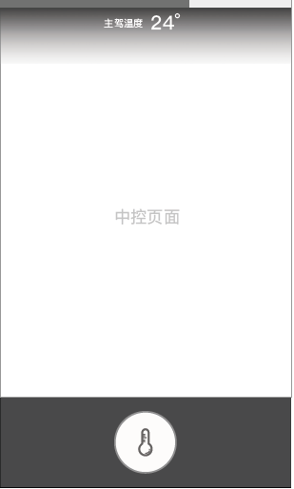

Example of 3.3.2

|  |  |
| --- | --- |
| Use Case ID | 3.3.3 |
| Use Case | As a customer, I want to adjust climate fan speed via knob |
| Pre-Conditions | 1. IVI is running 2. APP is working |
| Trigger | 1. The user sets short press as temperature. 2. Short press the knob 3. Turn the knob |
| Expected Behavior | The user can adjust the fan speed. |
| Post Conditions | Set 5 seconds as time out value, if user does not operate knob (short press) for 5 seconds, it will recover into volume mode. |
| Exceptions | If there is any event which has higher priority comes in, it will be terminated or performed in the background. |



Example of 3.3.3

|  |  |
| --- | --- |
| Use Case ID | 3.3.4 |
| Use Case | As a customer, I want to adjust volume after temperature or fan speed adjustment. |
| Pre-Conditions | 1. IVI is running 2. APP is working |
| Trigger | if user does not operate knob (short press) for 5 seconds |
| Expected Behavior | it will recover into volume mode. |
| Post Conditions | IVI volume should match knob adjustment steps. |
| Exceptions | If there is any event which has higher priority comes in, the searching will be terminated or performed in the background. |



Example of 3.3.4

|  |  |
| --- | --- |
| Use Case ID | 3.3.5 |
| Use Case | As a customer, I want to enter calm screen or display off quickly. |
| Pre-Conditions | 1. IVI is running 2. APP is working |
| Trigger | 1. The user sets long press as calm screen or display off. 2. Long press the knob (≥1000ms) |
| Expected Behavior | IVI screen will enter calm screen or display off. |
| Post Conditions | It can recover via touch effective screen zone or long press knob again. |
| Exceptions | If there is any event which has higher priority comes in, it will be terminated or performed in the background. |

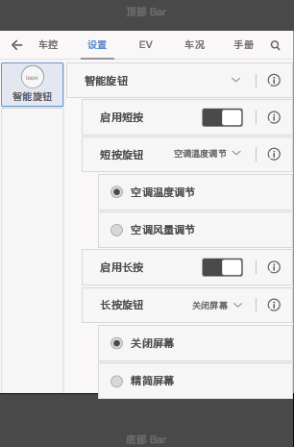

Example of 3.3.5

|  |  |
| --- | --- |
| Use Case ID | 3.3.6 |
| Use Case | As a customer, I want to restart the screen when ignition on. |
| Pre-Conditions | 1. IVI is running 2. APP is working 3. Knob is under “Volume” mode |
| Trigger | 1. The user sets long press as calm screen or display off. 2. Long press “Audio off” knob in the center of knob (≥10s) |
| Expected Behavior | IVI screen will restart. |
| Post Conditions | After restart, IVI application works normally. |
| Exceptions | If there is any event which has higher priority comes in, it will be terminated or performed in the background. |

# Supplementary instruction

## 补充说明1

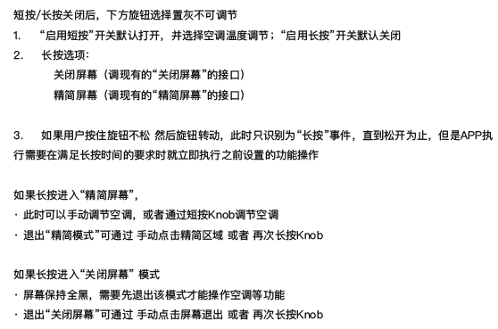

## 补充说明2

1. **“关闭屏幕”后，此时仅仅调节Knob相关功能，需要正常响应但不亮屏**
2. **方向盘按键调节音量与knob调节音量，两者并行不干涉，同时调节时根据组合关系进行计算（双倍增加、双倍减少……）**
3. **当Knob处于“调节风量/温度”模式下，在5秒time out退出之前, 此时用方向盘按键调节音量，音量正常增减并显示**
4. **在Knob调节风量/温度的同时，用方向盘调节音量, 按照谁占焦点谁显示 (此用户场景较少)**
5. **在浮窗显示温度/风量/音量过程中，此时唤醒语音, 会和语音弹窗并存。在语音弹窗显示时，此时调节knob, 温度/风量/音量浮窗会正常显示**
6. **在Knob中央为温度/风量图标的情况下，点击旋钮中央，无响应; 等切换回audio off图标，短按会audio off**
7. **在Knob中央为温度/风量图标情况下，此时长按旋钮中央位置，不会触发重启; 等切换回audio off图标，长按旋钮中央位置会触发重启**
8. **按压Knob 800ms内识别为短按，2000ms及以上识别为长按**
9. **在风量/温度调节模式下，5秒不操作，恢复为音量调节模式，knob中央切回Audio off图标**
10. **在RVC界面，长按事件不处理**

# Classification Key

|  |  |
| --- | --- |
| **Classification** | **Notes** |
| Proprietary | Information created or obtained in the normal course of business and not classified as Secret or Confidential |
| Confidential | Information that provides the Company with a competitive advantage, that supports its technical or financial position, and which, if disclosed without authorization, could cause damage to the Company. |
| Secret | Information of a strategic or highly sensitive nature that, if disclosed without authorization, would cause substantial, severe, or irreparable damage to the Company or its relationships. |

# Document Status Key

|  |  |
| --- | --- |
| **Status** | **Notes** |
| DRAFT | Document currently being worked on. Shall not be used as a solid reference to information included in this document. |
| AFR | Available For Review. Document information is not eligible for changes. Approving manager will revise this document and if all the information is found to be completely valid, then the document will change to REL status. If the document is found to have errors, the document will change to DRAFT status. |
| REL | Released. Document is completely valid at time of review, and is now available to be used as a solid reference of information. |

# Terms, Acronyms and Definitions

|  |  |
| --- | --- |
| **Term or Acronym** | **Definition** |
| IVI | In-vehicle infotainment |
| TCU | Telematics Control Unit |
| VR | Voice Recognition |
| TTS | Text to Speech |
|  |  |

# Contacts

For assistance or correction, please contact any of the following:

Geng Dekang

IVI Software Engineer

E-mail: dgeng1@ford.com

# Appendix

